**Project Planning Phase**

**Project Planning Template (Product Backlog, Sprint Planning, Stories, Story points)**

|  |  |
| --- | --- |
| Date | 15 February 2025 |
| Team ID | SWTID1741257978145975 |
| Project Name | Cook Book |
| Maximum Marks | 5 Marks |

**Product Backlog, Sprint Schedule, and Estimation (4 Marks)**

**Project Tracker, Velocity & Burndown Chart**

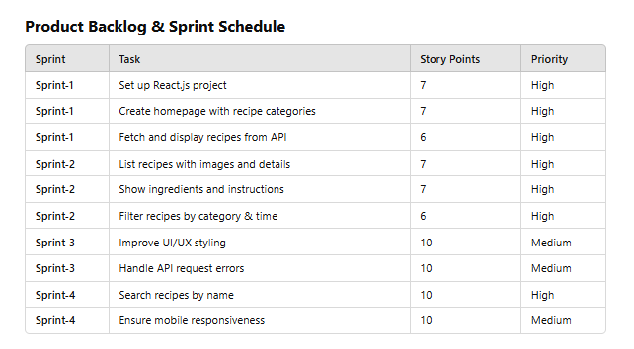

|  |  |  |  |  |  |  |
| --- | --- | --- | --- | --- | --- | --- |
| **Sprint** | **Functional Requirement (Epic)** | **User Story Number** | **User Story / Task** | **Story Points** | **Priority** | **Team Members** |
| **Sprint-1** | **UI Setup** | **USN-1** | **Set up React.js project structure with necessary dependencies** | **7** | **High** | **Pratiksha** |
| **Sprint-1** | **Home Page & Navigation** | **USN-2** | **Create a homepage displaying recipe categories & trending recipes** | **7** | **High** | **Pratiksha** |
| **Sprint-1** | **API Integration** | **USN-3** | **Fetch and display recipe data from API** | **6** | **High** | **Pratiksha** |
| **Sprint-2** | **Recipe Listing** | **USN-4** | **Dynamically list recipes with images and details** | **7** | **High** | **Pratiksha** |
| **Sprint-2** | **Recipe Details Page** | **USN-5** | **Create a detailed page showing ingredients, instructions, and cooking time** | **7** | **High** | **Pratiksha** |
| **Sprint-2** | **Filtering Feature** | **USN-6** | **Enable filtering of recipes based on category, ingredients, and time** | **6** | **High** | **Pratiksha** |
| **Sprint-3** | **UI Enhancement** | **USN-7** | **Improve UI/UX with better styling and animations** | **10** | **Medium** | **Pratiksha** |
| **Sprint-3** | **Error Handling** | **USN-8** | **Implement error handling for failed API requests** | **10** | **Medium** | **Pratiksha** |
| **Sprint-4** | **Search Feature** | **USN-9** | **Allow users to search for recipes by name** | **10** | **High** | **Pratiksha** |
| **Sprint-4** | **Responsive Design** | **USN-10** | **Ensure responsiveness for mobile & tablet views** | **10** | **Medium** | **Pratiksha** |

